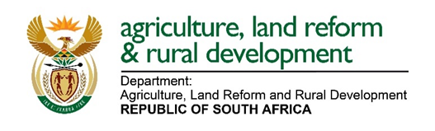
REPUBLIC OF SOUTH AFRICA
DEPARTMENT OF AGRICULTURE, LAND REFORM AND RURAL DEVELOPMENT
FORM C
DECLARATION MADE IN THE PRESENCE OF A COMMISSIONER OF OATHS

The applicant hereby declares that the application for renewal of the agricultural remedies listed in Form A conforms to the following requirements as stipulated in the “Regulations relating to agricultural remedies” of 25 August 2023:
- It is disclosed on Form A whether the remedies submitted for renewal does or does not contain ingredients and/or co-formulants or biological organisms regarded as substances of concern in sufficient quantities to warrant the final classification of the remedy a substance of concern.
- No new scientific evidence is known to be available on the agricultural remedy’s potential health effects for vulnerable groups, especially children, other than what has already been disclosed or is being disclosed in the current application.
- The details furnished with these applications, as well as the labels which are being used in connection therewith, do not deviate in any manner whatsoever from the congruent details which have already been registered or approved for the remedies concerned.
Applicant company |  | Title of company representative
Full name of company representative |  | Signature
Date |  | Tel No.

I certify that the deponent has acknowledged that he/she knows and understands the contents of this declaration which was sworn to/affirmed before me and the deponent's signature was placed thereon in my presence.
Commissioner of oaths |  | Designation
First names and surname |  | Business address (street address)
Date |  | Place

